M.B.O. – Management by Objectives for 2016 - 2017
Windsor Chapter 141
Our commitment to succeed as a chapter continues to grow. We have an enthusiastic board with active participants. With respect to history, we have spent far too much time over the past couple of years trying to accumulate missing data. We are still working towards finding some missing information, but are focusing our efforts on developing a program to implement and carry forward. It will be a work in progress for this year with hopes of needing to “tweak” the format as needed in future years. The efforts of the recent past years have been very helpful in understanding the need for being organized with our documents and how to accomplish this.
Our objectives for the 2016-2017 Chapter Years are as follows:
- Continue to develop and post archives on our web site
- Interview a past president (or two) and publish in our newsletter
- Update our chapter timeline
- Work with the chapter on expanding our history night along with our past presidents night
- Interview fellow chapter members and publish in our newsletter
- Develop a monthly “This day in History, ?? Years Ago” segment to be added to the monthly newsletter
- Review this list at minimum frequency of twice monthly and prioritize items not completed.

Yours Truly,
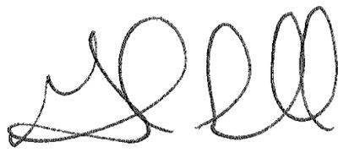
Gord Snell
Windsor Chapter 141, History Committee Chair

